Property Connect

User Guide



Contents
LOGIN 3
HOME 3
Creating an Order 4
Editing Draft Orders 6
Viewing Billed Orders 6
SEARCH ORDERS 8
HISTORY 9
PRORATED COST 10
SETTINGS 11

Login
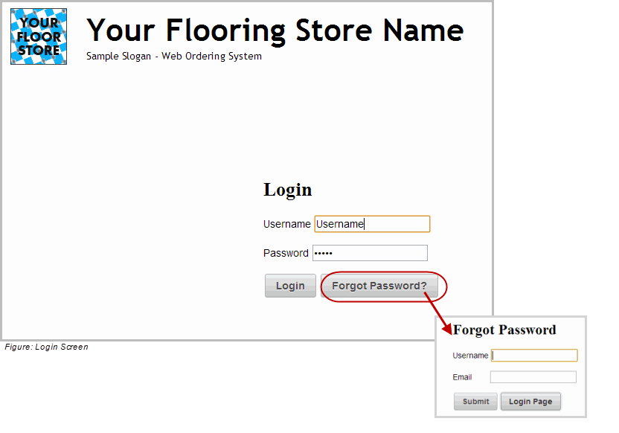
Type the user name and password and then click the Login button.
To retrieve a password, click forgot password and then enter user name and email address.

Home
The Property Connect Home screen is displayed. The options and information available depend on the permissions specified for the user in the admin page. With all permissions available, Draft Orders are listed first, then a listing of properties with their billed orders. Draft orders can be edited, deleted or viewed from this screen. Billed orders can be viewed. Unbilled orders can be seen via the search order section. Click the create order tab to start a new order.
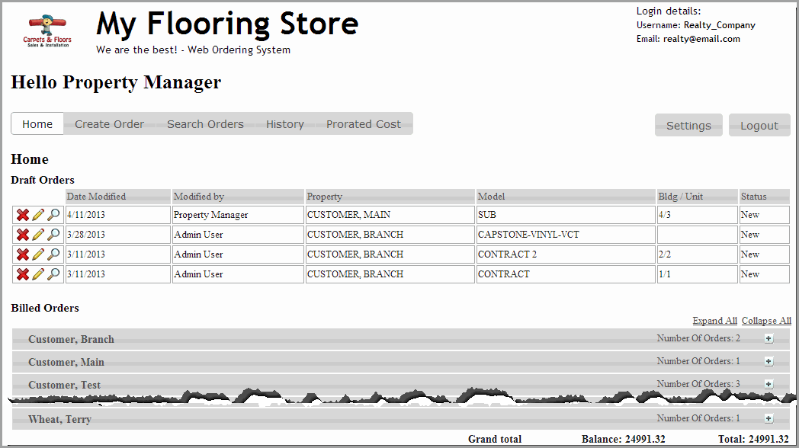

Creating an Order
Click the Create Order Tab
The create order screen will display.
Use the drop down box to list the properties. Select a property by clicking on it. Properties are listed in alphabetical order. Then use the drop down box to list available models. If a sub model is available, an additional drop down box will display to allow choosing the correct sub model. Select the sub model by clicking on it.

The properties available are set by your Property Connect Administrator (The Floor covering Store).
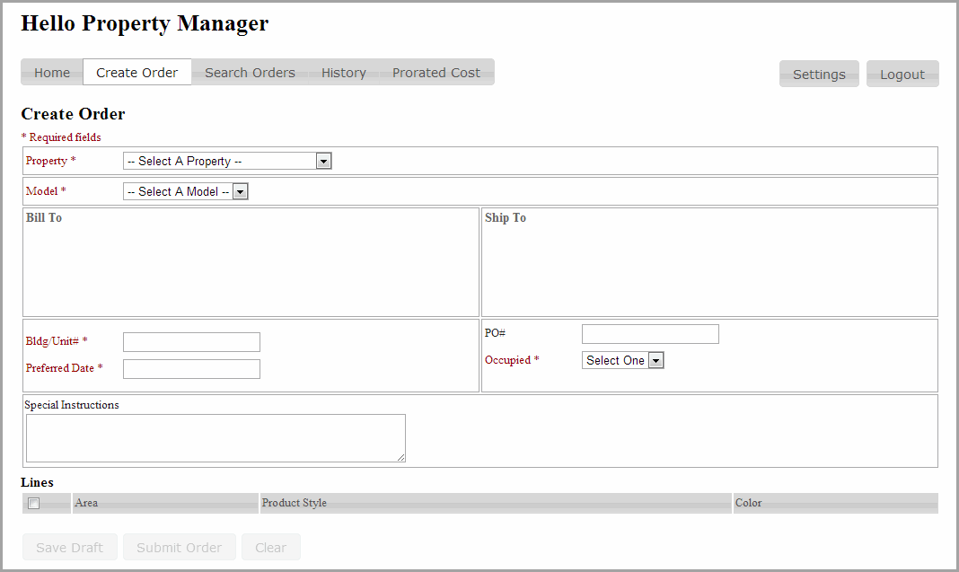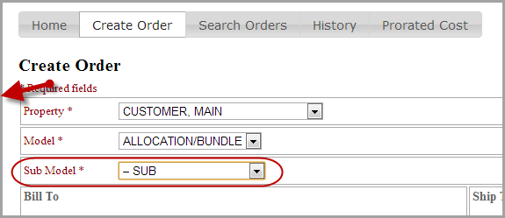
Figure: Create Order Screen
Much of the information will be automatically populated based on the model choice.

Required information is listed in red and has an * next to the field name. The submit button will be disabled until all required information is entered.

Information to be entered in tab order (not all fields may be available):
Bldg/Unit #: If available, this is a required field.
Preferred Date: Use the calendar to select the date. If available, this is a required field. This will import into the estimated delivery date field in Order Entry.

Preferred Time: Use the down arrow to select an option from the list of All day/AM/PM. The date must be the next day or later. This will import into the estimated delivery date field in Order Entry.
PO#: This is an optional field unless it is required on the RFMS customer record for this company or property.

Occupied: Use the down arrow to select an option from the list of Yes/No/Unknown. This information is helpful in the scheduling process. This is a required field.

Special Instructions:
Enter information as needed here. It will transfer to order entry in the web order screen as directions for processing the order. It can be viewed from the all notes and remarks section in Client Management Remote Actions, once the order is created in customer orders.

Lines:
Options for that model will be shown, in the example new order detail screen there are two carpet options.
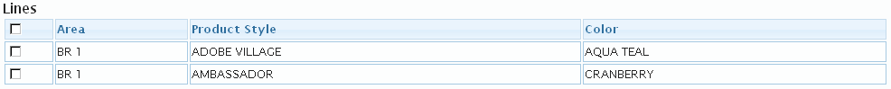

Select the items to order by checking next to them or select all by clicking in the box next to Area.

New Draft Options

Save the New Draft Order to be edited or approved and submitted later. Saving the New Draft assigns it an ID, which can then be used to search by.

Cancel to return to the Home screen.

Submit Order. Sends the order to the supplier. This cannot be done until all required fields are completed.
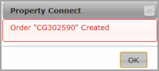
A message will be displayed when an order has been created. The order will go to the dealer for credit checking and processing.

If set, a confirmation email will be received. This recipient email address may be changed under Settings. Click here to see details.

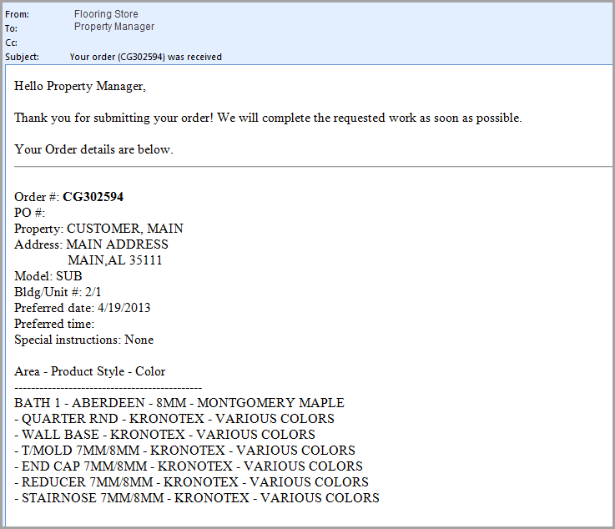

Editing Draft Orders
From the home page see the listing of Draft orders.

Click the red X to delete a draft order.
Click the edit button to edit a draft order.
Click view to see the detail of an individual order.
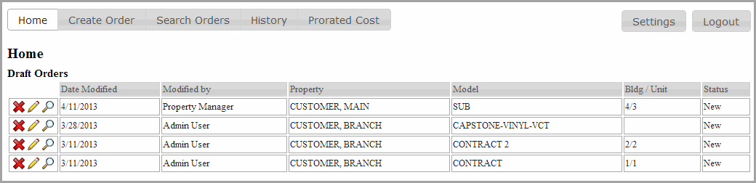

Viewing Billed Orders
From the home page see the listing of billed orders.

Click the + sign to see the listing of billed orders for a property. Click the + sign again to collapse the list. Alternatively, click ‘Expand All’ to see all listings and ‘Collapse All’ to hide all listings.
Click view to see the detail of an individual order.
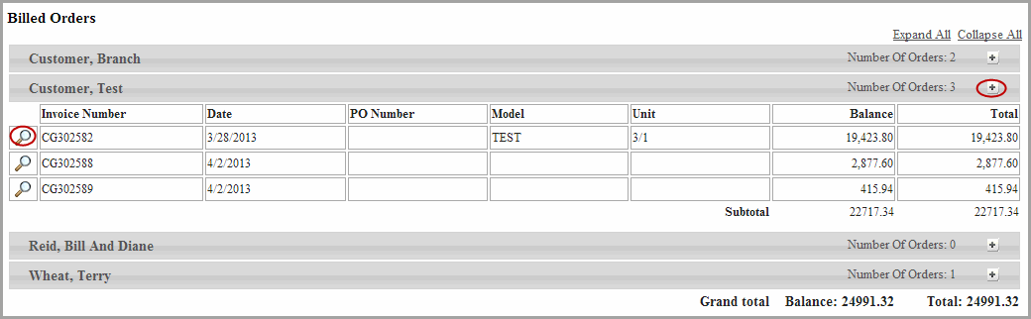

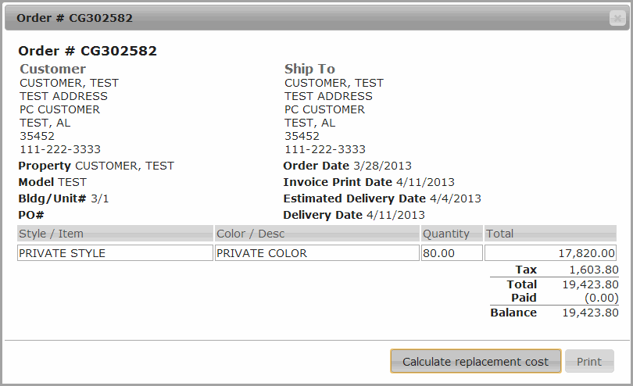
Figure: View Billed Order
Click the print button to print a copy of this order.

Search Orders
Search orders by entering any text into the search box. Then click the search button. To reset the search fields, use the clear button.

Select filter information for type and property by using the drop down arrows.
Type: Options are All, Unbilled, Billed, Paid
Property: Select one of the available properties or all

The number of each listed is controlled by the number in the Show _ Entries box which can be adjusted to show up to 100 orders per screen. The numbers of the entries is shown at the lower left of the listing. To start searching within search results, simply start typing in the search box within the search results.

Use the scroll bar to see more of the listings.
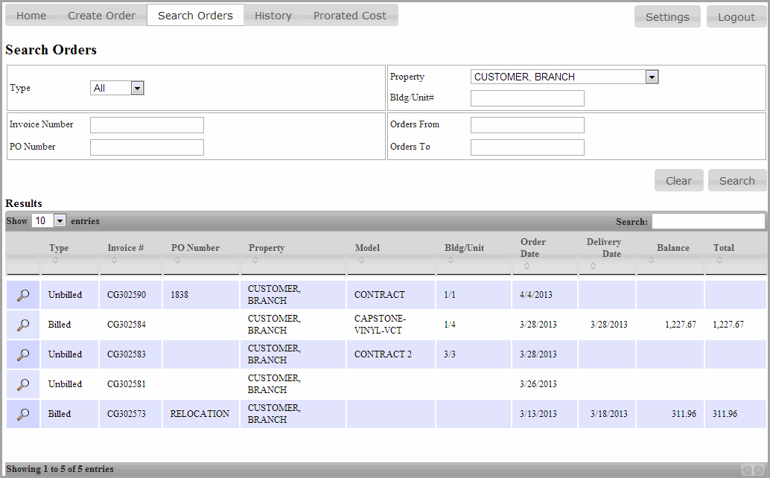
Figure: Search Screen
Click any of the column headings in the list to sort by that column. This also sets the search field to search by that column. For example, click on order date. The listed orders will be sorted by order date. Then enter 8 in the search box to limit the list to only orders in August.

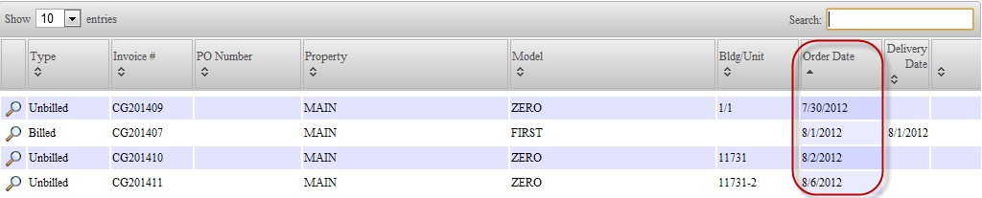

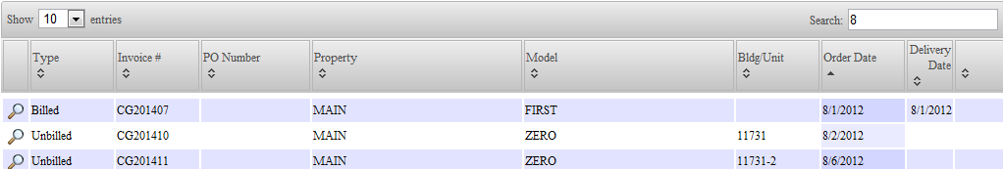

Click the view button to see the details of an order.
If an order has not been billed, a preliminary total may be shown if the store has printed an acknowledgement.

History
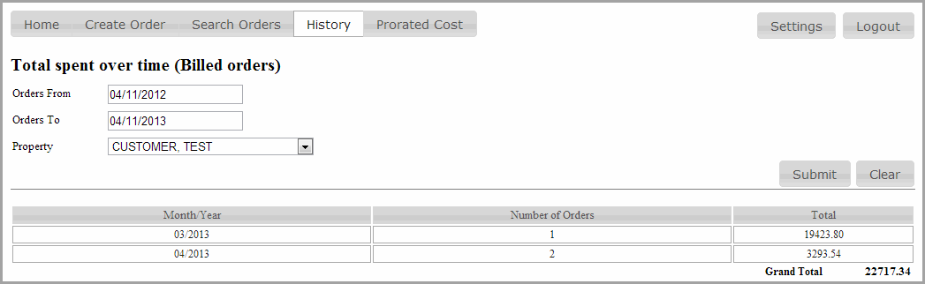
Click the History tab to search for Billed orders by date and will view the total spent each month. Select a time frame and a specific property.

Select the property using the down arrow to select from the drop down list. The time frame defaults to one year.

Click the submit button to display the list. One row per month will be listed.
Click the clear button to start a new search.

Prorated Cost
Property Connect has the ability to create an invoice to tenants for replacement costs. The cost to the tenant can optionally be prorated based on the move out date and the life expectancy of the product. A generic invoice or lines on an invoice can be created for replacement costs of products not associated with property connect.
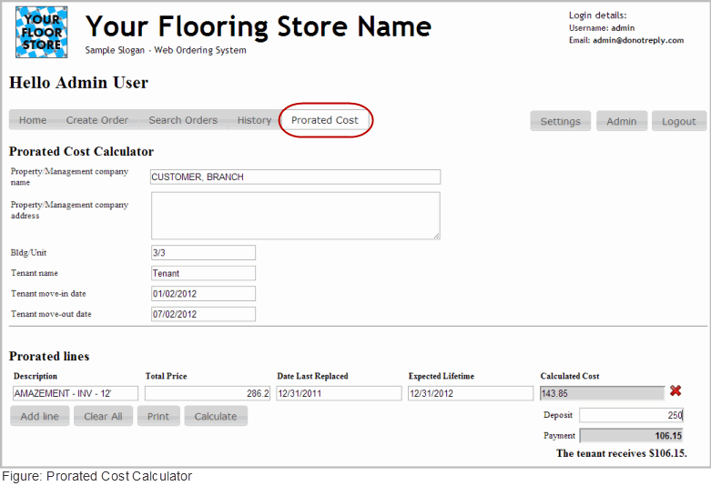
- Pulling products from a past order.
  - From Search Orders, find a past order using for example the Bldg/Unit.
  - Click the view button. This displays the order details with a Calculate Replacement Cost button. Click it.
  - The Prorated cost calculator screen is displayed with all the possible lines from the past order.
  - Using the red x, delete the lines not needed.
- Enter product Manually
  - Click the Prorated Cost tab start a new or On an order with lines from a past order
  - Click Add Line
  - Manually enter Description, Total Price, and to prorate the total cost per day enter the date last replaces and the expected life time.
- To prorate the cost to be paid by the tenant
  - Enter in the date last replaced and the expected lifetime date to calculate the amount of time to prorate against.

  - Enter the tenant move-in and move-out date to calculate their time in the unit.
  - Click the calculate button.
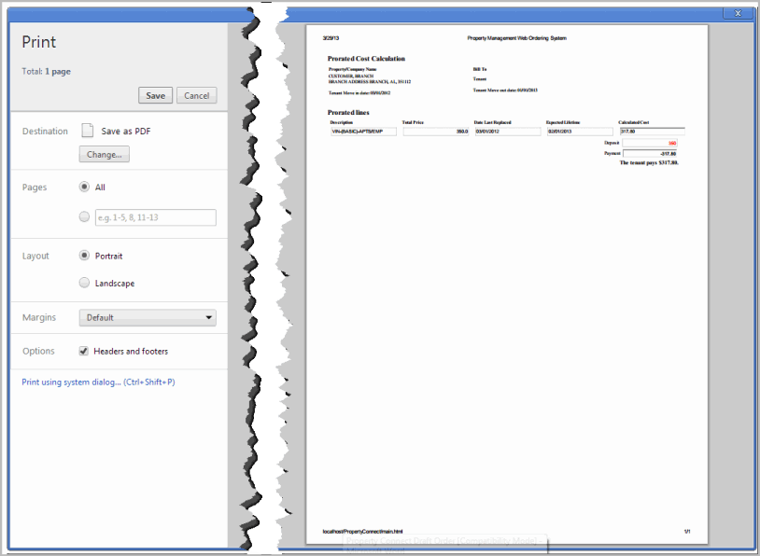
- Print an Invoice for the Tenant
Note: These invoices are not saved.

Settings
To change a password or email address, click on Settings in the upper right hand corner of the screen. Click Change Email or Change Password. This email address will receive a notification of orders entered and also be included on the submitted order.
Then enter new value twice. Click Save to save the new value or click X to exit and keep the old information.

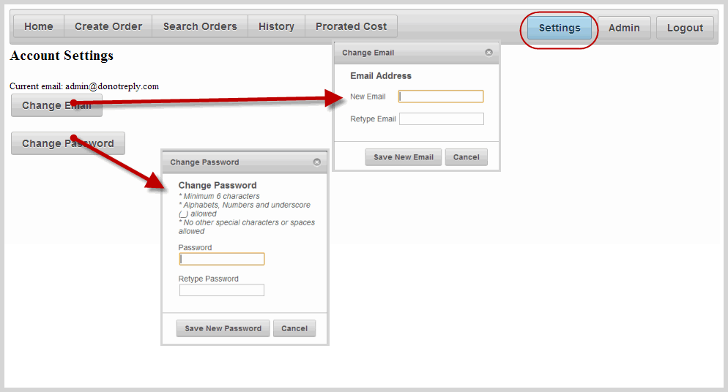
Figure: Settings Screen

